AI-powered FAQ and customer support automation
INTRODUCTION
Project Title: AI FAQ ASSISTANT
Team ID: SWTID-2026-2594
Team Leader:
NAME | MAIL ID
Shivarishi T S | Anandgamer218@gmail.com
Team Members:
NAME | MAIL ID
Prajwal S | prajwal03102005@gmail.com
KARTHIKEYAN K | kannanauto1989@gmail.com
Mohanbabu N | shallikissyou7@gmail.com

1.PRROOJJEECCTT OVVEERRVVIIEEWW:
Project Overview
Purpose: The AI FAQ Assistant is a backend-focused web application developed using Node.js, Express.js, and MongoDB,
designed to provide a secure and scalable solution for managing
frequently asked questions (FAQ) data through RESTful APIs. The
system enables users to create accounts, log in securely, and access protected routes using JWT-based authentication, ensuring that only
authorized users can perform operations. It supports complete CRUD functionality, allowing users to add new questions, view their FAQs, update question and answer details, and delete entries when needed.
  - Key Objectives:
••Provide secure JWT-based user authentication and authorization for protected API access.
••Enable efficient FAQ management and retrieval through RESTful CRUD operations.
• Ensure user-specific data isolation so users or administrators manage only their assigned questions.
••Implement scalable backend architecture using Node.js, Express.js, and MongoDB.
••Deliver fast and reliable API responses with proper validation and error handling.
  - Target Audience:
••Customers & Users – Get quick answers to frequently asked questions.
••Students – Find information about courses, assignments, fees, and college services.
••Employees – Get answers about company policies, HR procedures, and internal processes.
••Businesses & Organizations – Automate customer support and reduce repetitive queries.
••Website Visitors – Quickly find information about products, services, pricing, and policies.
- PROJECT ARCHITECTURE
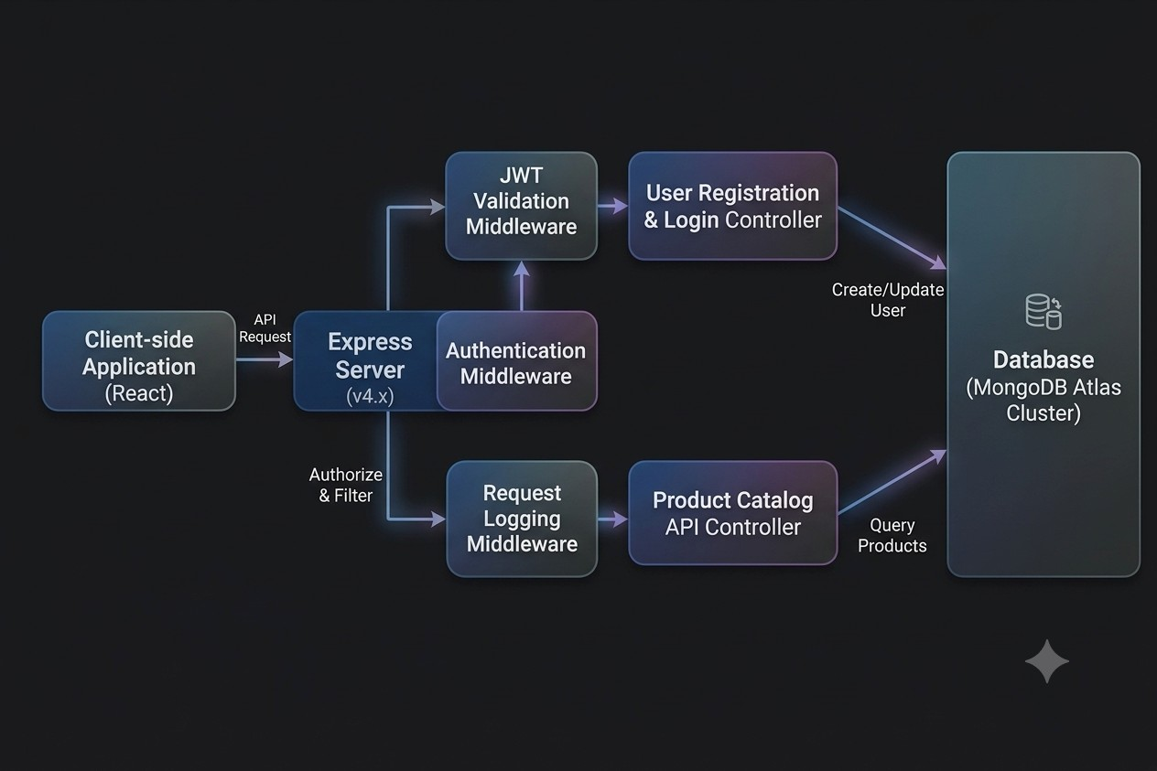
2.1.Express Server :
In the AI FAQ Assistant project, the Express server acts as the primary
backend hub, handling requests from the frontend and tools like Postman. It manages routing for key actions—such as login, question creation, and data retrieval—while organizing the overall application architecture. By routing traffic through authentication middleware for security checks, the server serves as the central control point for the application flow.
2.2.Auth Middleware:
The Auth Middleware secures the FAQ Assistant system against
unauthorized access. It intercepts requests for protected actions—such as creating or updating questions—and validates the user's authentication token. Valid requests are forwarded to the controller, while invalid ones are blocked.
Otherwise, the request is rejected, ensuring that only authenticated users can manage questions within the system.
2.3.Auth Controller:
The Auth Controller acts as the authentication gateway for the system,
handling user signup and login flows. It verifies submitted credentials against stored database records and issues JWT/session tokens upon successful validation. This ensures controlled access to restricted system endpoints and maintains robust user security.
2.4.Question Controller:
The Question Controller manages all question-related operations within
the FAQ Assistant system. It handles CRUD operations, including adding, updating, retrieving, and deleting questions. Upon receiving a request, the controller processes the logic and interacts with the MongoDB database to store or fetch data, ensuring accurate and up-to-date question records.
2.5.MongoDB:
This project uses MongoDB to store user accounts and question metadata. The backend controllers leverage MongoDB’’s flexible document model to handle data operations like creating, updating, and querying question records. This guarantees efficient, secure, and scalable storage for the FAQ Assistant system.
2.6.TECHNICAL ARCHITECTURE
Backend Architecture (Node.js + Express)
•• Controllers: Handle authentication and question logic
•• Models: Define database schema
•• Routes: API endpoints for authentication and questions
•• Middleware: JWT verification and error handling
•• Configuration: Environment variables and database connection
Database Architecture (MongoDB) Users Collection:
•• _id
•• name
•• email
•• password (hashed)
•• timestamps
Questions Collection:
•• _id
•• userId (reference to user)
•• name
•• Question
•• Answer
•• description
•• timestamps
Relationship: One User →→ Many Questions
Indexes:
•• email (unique)
•• userId
•• Category
ER Diagram
ER diagram showing User →→ Question relationship:
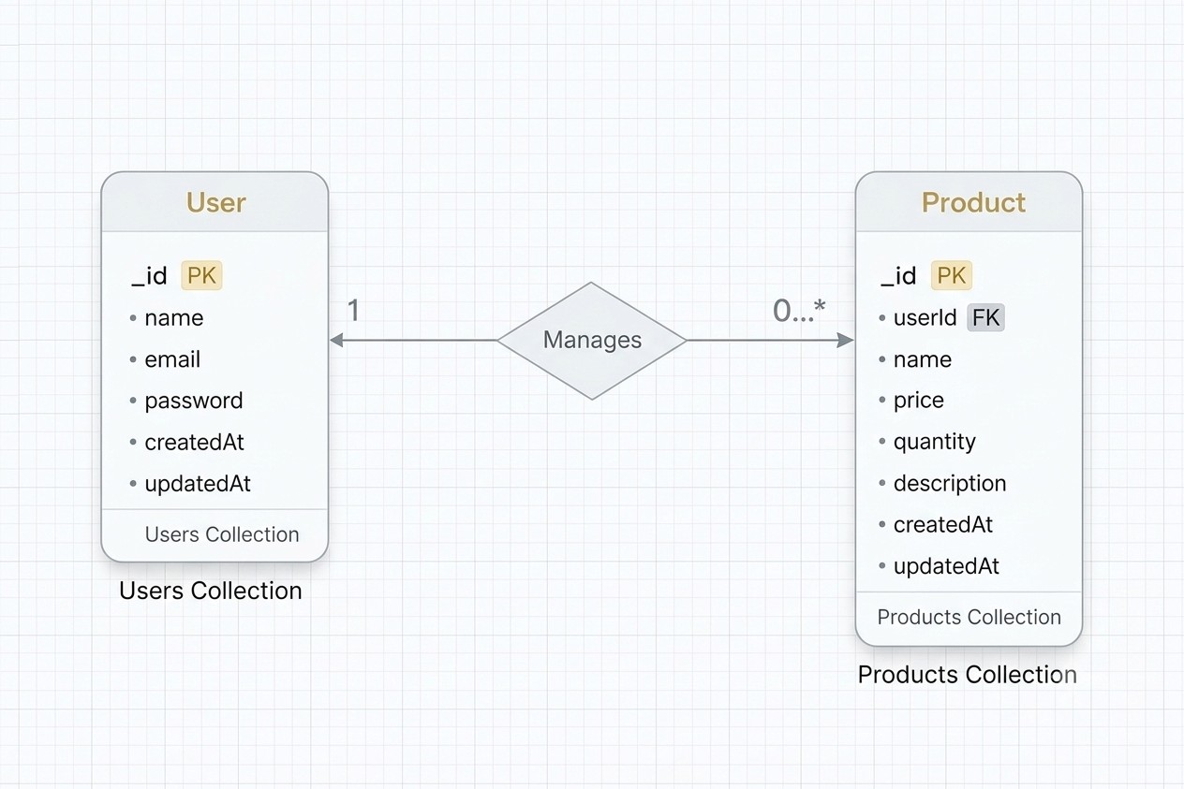
3. SETUP INSTRUCTIONS
3.1.Prerequisites:
Before setting up AIFAQAssistantensure that the following tools
and technologies are installed on your system:
o Node.js –– JavaScript runtime environment. o MongoDB –– Database for storing user data, projects, and chat messages.
o Git –– For cloning and version control. o Express.js –– Backend framework for handling APIs and server logic. o Mongoose –– ODM (Object Data Modeling) library for MongoDB. o Visual Studio Code –– Recommended IDE for development.
3.2.Installation steps
3.2.1.Node.js
•• Knowledge: basic JavaScript (variables, functions, promises/async-await), basic command-line use (terminal / PowerShell), JSON, and git (recommended).
•• System: Windows / macOS / Linux (x64 or arm64); 2GB+ RAM recommended; internet to download installers.
•• Tools to have ready: a terminal (CMD/PowerShell/WSL on Windows, Terminal on macOS/Linux), a code editor (VS Code recommended).
Step-by-step installation
Windows — easiest: official installer (or use npm-windows for version

management)
Official installer (quick)
- Visit the official Node.js downloads page and download the Windows .msi (choose the LTS build).
- Run the MSI and accept defaults (it will install node and npm and add to

PATH).
3. Open PowerShell or Command Prompt and verify:
node -v
npm -v
you’’re done. nodejs.org
If you want multiple Node versions / safer global installs — use npm for Windows
- Install npm-windows (download and run the installer from the npm-windows releases).
- After install, open a new admin PowerShell or CMD and use:
npm install lts
npm list
npm use <version> # e.g. npm use 18.16.0 OR `npm use lts` if supported
node -v
npm-windows lets you switch versions without re-installers. GGiittHHuubb++11 npm -v

you’’re done.
3.2.2.MongoDB:
–– Knowledge Prerequisites
–– Basic database concepts: collections, documents, CRUD (Create, Read, Update, Delete).
–– Basic command line/terminal usage.
–– JSON knowledge (MongoDB stores data in BSON, similar to JSON).
–– (Optional) Networking basics: ports, IP binding, authentication.
System Prerequisites
–– OS: Windows (x64/arm64 supported).
–– Processor: 64-bit, 1 GHz+ recommended.
–– RAM: Minimum 2 GB (4 GB+ recommended for dev; higher for prod).
–– Disk space: At least 5––10 GB free (MongoDB stores large amounts of data).
–– Port: MongoDB runs on 27017 by default (make sure it’’s free/unblocked).
Software Prerequisites
–– Administrator (to install packages/services).
–– Package manager (apt, yum, Homebrew) OR direct installer.
–– MongoDB Shell (mongosh) –– required to interact with MongoDB.
–– MongoDB Compass (GUI) –– optional but recommended for beginners.
–– Docker (optional) –– for containerized setup.
3.2.3.Git
System prerequisites
–– OS: Windows
–– Permissions: Administrator (Windows)
–– Network: Internet access (for cloning/pushing remote repos like GitHub, GitLab, Bitbucket).
Software prerequisites
–– Text/code editor (VS Code recommended).
–– SSH client (optional, for GitHub/GitLab SSH connections).
Github account creation:
- Sign in to GitHub
•• Go to GitHub.
•• Log in to your GitHub account. If you don't have one, you can sign up for free.
- Create a New Repository
•• Once logged in, click on the + icon in the top right corner of the page.
•• Select "New repository" from the dropdown menu.
- Fill in Repository Details
You'll need to fill out the following fields:
•• Repository Name: Choose a name for your repository (e.g., my-project).
•• Description (optional): Provide a brief description of your project (e.g., "A cool web app").
•• Public or Private: Choose whether your repository will be public (anyone can see it) or private (only you and collaborators can access it).
•• Initialize with README: If you want to add a README file (which is helpful for explaining your project), check this box.
•• Add .gitignore (optional): You can choose a template for your .gitignore file, depending on your project's language or framework (e.g., Python, Node, etc.).
•• Choose a License (optional): You can choose a license if you'd like to specify how others can use your code.
- Create the Repository
•• Once you've filled everything out, click the Create repository button.
- Clone the Repository (Optional)
•• After the repository is created, you'll be taken to the new repository's page.
•• To clone it to your local machine, copy the clone URL (either HTTPS or SSH) from the "Code" button.
•• In your terminal, run the following command:
•• git clone<repository-url>
- Start Adding Files
•• Now you can start adding files to your repository either through the GitHub website or by pushing files from your local machine.
That's it! You've created a new GitHub repository. Let me know if you need help with the next steps, like pushing files to GitHub.
3.2.4.Express.js –– Mongoose –– Visual Studio Code
–– Prerequisites (Theory)
–– JavaScript & Node.js →→ needed since Express runs on Node.
–– MongoDB knowledge →→ Mongoose is an ODM for MongoDB.
–– REST API concepts →→ to design routes/endpoints.
–– Visual Studio Code →→ editor to write and manage the project.
–– Node.js & npm installed →→ to run server and install packages.
–– MongoDB installed or Atlas account →→ for database.
•• Installation Steps:
# Clone the repository git clone
# Install client dependencies cd client npm install
# Install server dependencies cd
../server npm install
#Install server dependencies cd
../server npm run dev

4.FEATURES
4.1.Core Features:
S.No | Feature | Description
1 | User Authentication | JWT-based register and login system
2 | Question CRUD | Add, view, update and delete questions
3 | Private Data Access | Users access only their own questions
4 | Question Search | Search questions by name
5 | Secure API | Middleware protected routes
- 2.Roles and Responsibility
4.2.1.User
    - Registration: Register using name, email and password
    - Login: Login using registered credentials
    - Add question: Create question with question, answer and category
    - Edit Answer: Update existing FAQ answer
    - Delete question: Remove FAQ questions
    - Search question: Search FAQ qustions
4.2.3.User Flow
  - The user sends a register/login request.
  - The backend generates a JWT token.
  - The user sends a token in the Authorization header.
  - Middleware verifies the token.
  - The controller performs CRUD operations.
  - MongoDB stores or retrieves question data.
  - API sends response.

5.FOLDER STRUCTURE
server/
│
├── node_modules/
├── src/
│ ├── controllers/
│ ├── db/
│ ├── middlewares/
│ ├── models/
│ ├── routes/
│ └── server..jjss
│
├── ..eennvv
├── ..ggiittiiggnnoorree
├── package-lock..jjssoonn
└── package.json
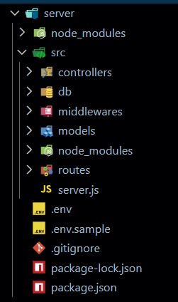
5.1.Initialize Node.js Project:
Open terminal inside the server folder and run:
nnppmm init -y
This creates the package.json file which manages project dependencies.
5.2.Install Required Packages: Install backend dependencies:
npm install express mongoose cors dotenv jsonwebtoken bcryptjs
Package Purpose:
●● express →→ Backend framework
●● | mongoose →→ MongoDB connection
●● | cors →→ Cross-origin requests

●● | dotenv →→ Environment variables
●● | jsonwebtoken →→ Authentication
●● bcryptjs →→ Password hashing
5.3.Create Environment File:
Create a ..eennvv file in the root of the server folder.
Example:
PPOORRTT=5000
MMOONNGGOO__UURRII=your_mongodb_connection_string
JJWWTT__SSEECCRREETT=your_secret_key
Backend Development
5.4.Setup Express Server:
Inside src/server.js, create the basic Express server.
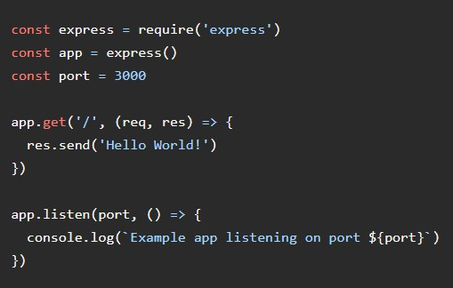
5.5.Create Controllers:
Inside: src/controllers/ Create:
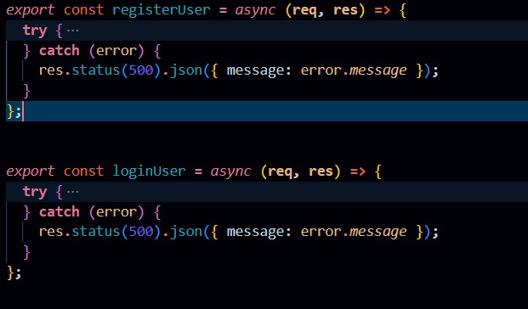
a
u
t
h
.
c
o
n
t
r
o
l
l
e
r
.
j
s
5.6.Create Routes
Inside: src/routes/ Create: auth.routes.js
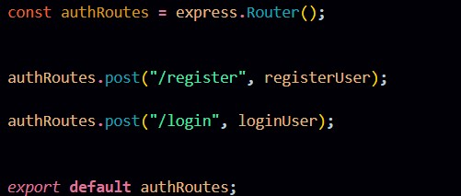
5
.
7
.
A
u
t
h
R
o
u
t
e
s
:
Auth routes manage user authentication endpoints, such as signup and login. They pass incoming requests to the Auth Controller to handle user registration and issue JWT tokens for securing protected application routes.
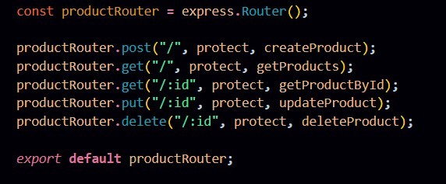
q
u
e
s
t
i
o
n
.
r
o
u
t
e
s
.
j
s
5.8.Question Routes:
Question routes handle the complete CRUD lifecycle for FAQ content. Access is restricted via authentication middleware, ensuring users are authorized to view or modify only their designated question records.
Connect Routes to Server
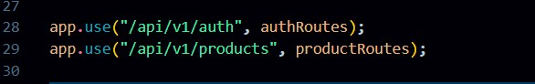
I
m
p
o
r
t
a
l
l
r
o
u
t
e
s
i
n
t
o
s
e
r
v
e
r
.
j
s
These configurations mount the authentication and question APIs onto the Express server under versioned base paths. Requests to /api/v1/auth handle user authentication, while /api/v1/questions controls FAQ operations, maintaining an organized and scalable application structure.
Database Configuration and Setup
●● Create MongoDB Atlas cluster ●● Add connection string to .env
●● Connect DB before API testing.
Database Connection:
Create a file inside: src/db/ddbb..jjss
Purpose: Connect backend to MongoDB using mongoose.
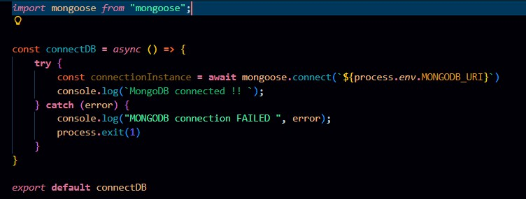
The connectDB function handles database initialization by connecting Mongoose to MongoDB using environment variables. It prevents the application from starting until a successful connection is made, logging any initialization errors to the console.
5.9.Create Models:
Inside src/models/ create:
●● User.js
●● Question.js
User Model:
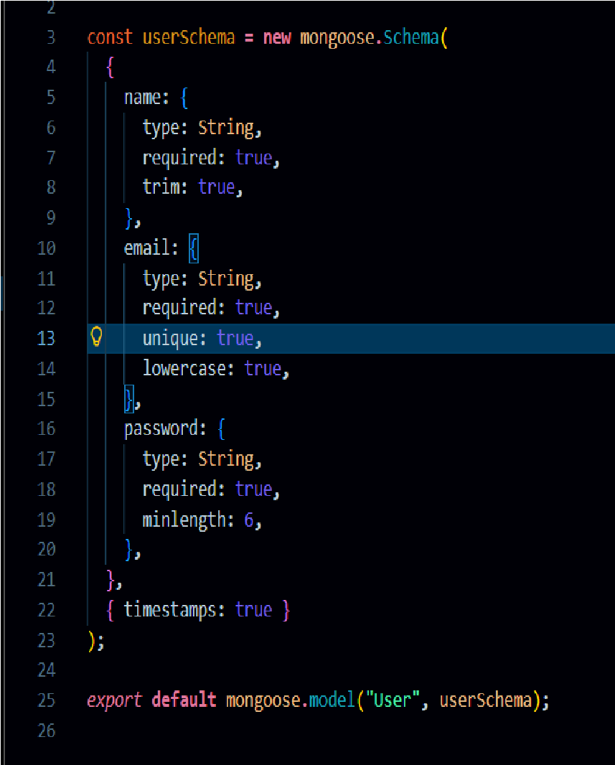
- 10.User Schema:
The User schema establishes the database structure for user credentials, storing the user's name, email, and hashed password. Designed for secure authentication, it includes built-in timestamping to track record updates and user creation.
Question Model:
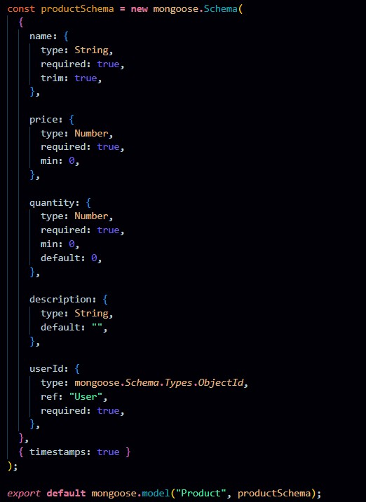
Question Schema:
The Question schema represents faq assistant items and includes fields like name, price, quantity, description, and a userId reference. It ensures each question is linked to its owner, enabling private data access and management.
5.11Use Thunder Client to test APIs:
Test APIs:
  - 1.Register User:
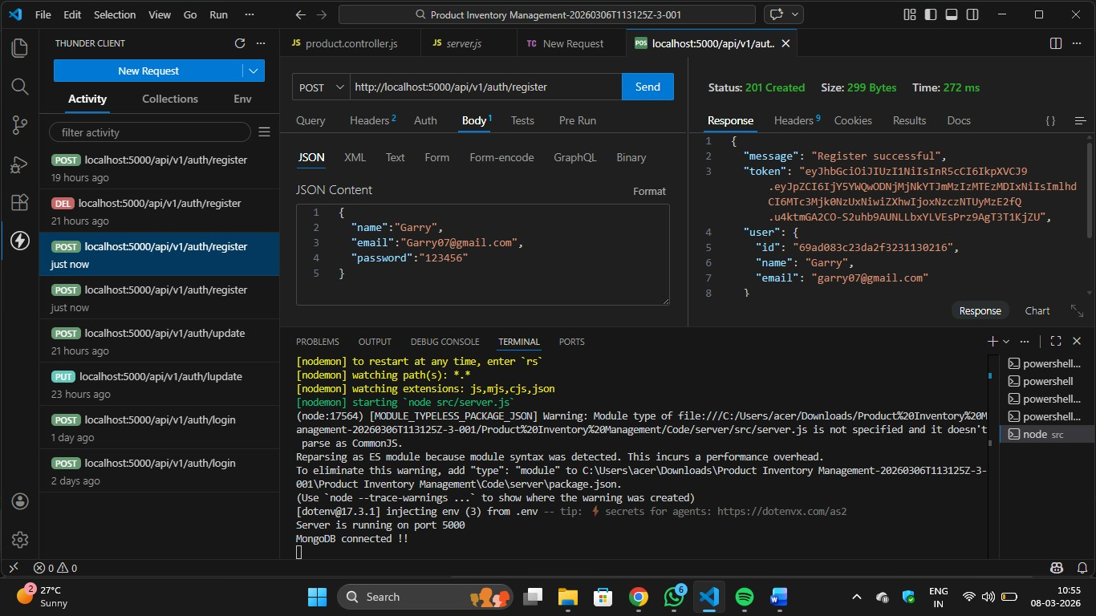
Register:
The register functionality allows new users to create an account by submitting their details, which are validated and securely stored with a hashed password. It ensures unique user creation before granting access to the system.
5.11.2.login user:
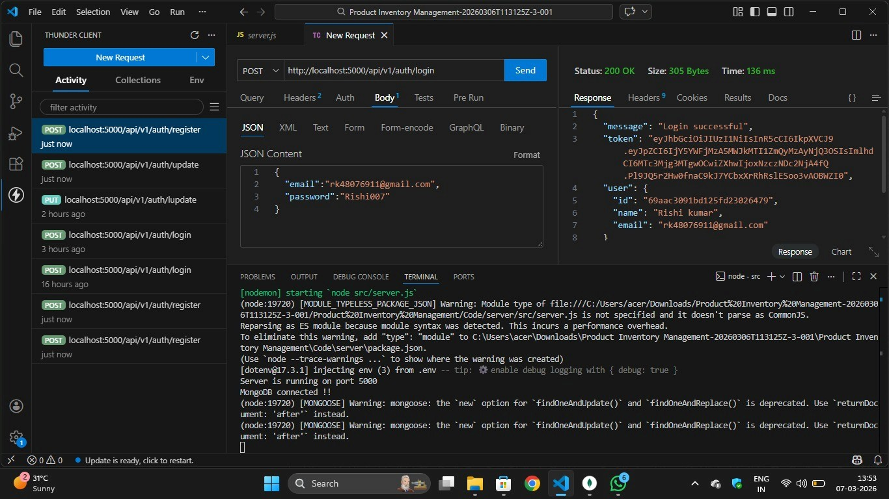
Login:
The login functionality verifies user credentials and generates a JWT token upon successful authentication. This token is used to access protected routes securely.
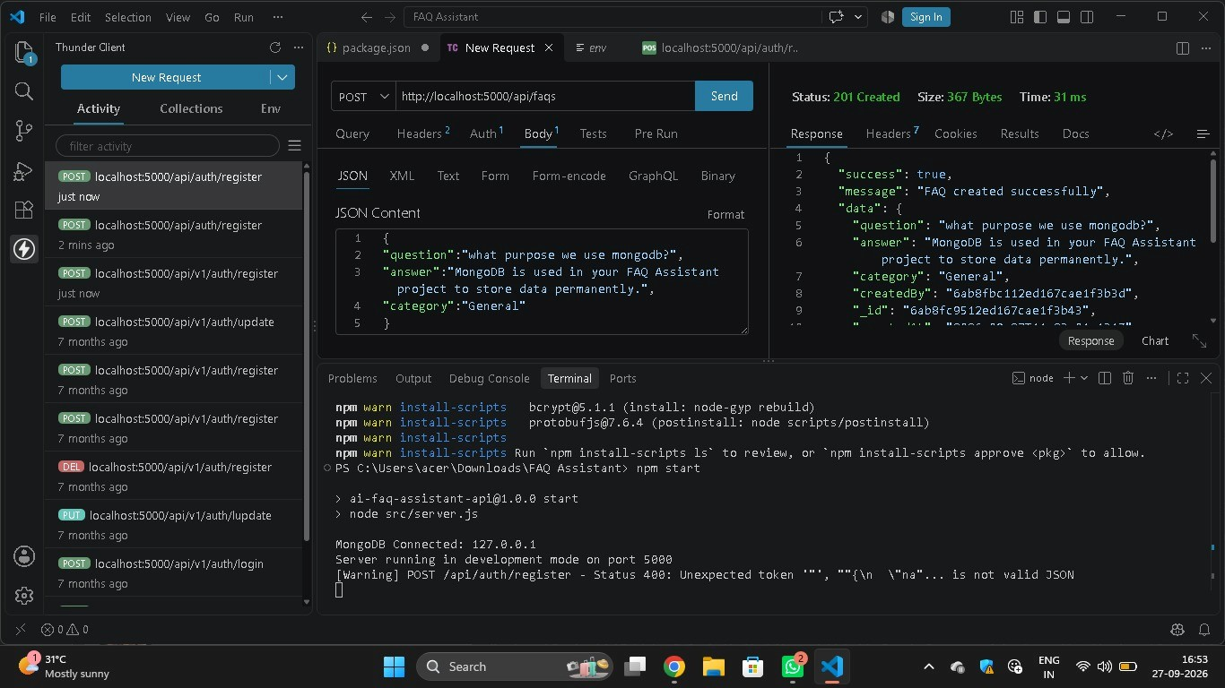
5
.
1
1
.
3
.
C
r
e
a
t
e
Q
u
e
s
t
i
o
n
Create question:
Allows an authenticated user to add a new question to their faq
assistant by submitting question details.
5.11.6. Delete question:
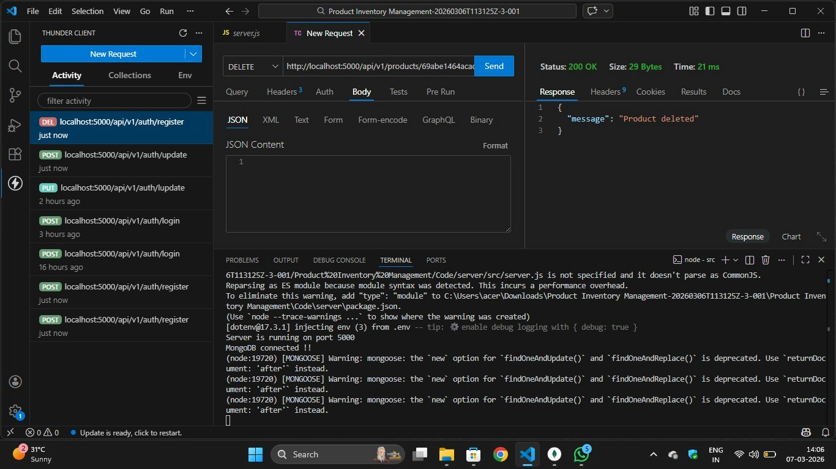
Delete question:
Allows users to permanently remove a question from their faq
assistant. The operation is protected to ensure only the question owner can delete it.
5.11.7.MongoDB Compass:
